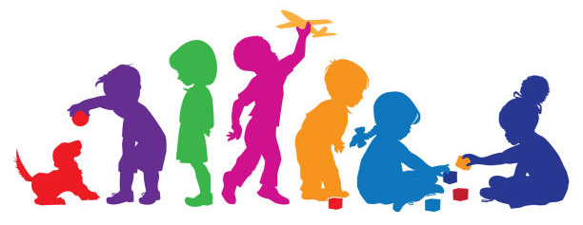
Online Resources for Families

Communication and Occupational Therapy Resources: Information and activity resources for speech, language, fine motor, social emotional, literacy and more!
https://sites.google.com/gshare.blackgold.ca/black-gold-otslp-supports/home/occupational-therapy?authuser=0

Speech and Language Resources https://open.alberta.ca/publications/talk-box-a-parent-s-guide-to-creating-language-rich-environments-preschool

https://www.asha.org/public/speech/development/- developmental milestones

Reading
https://www.readingrockets.org/audience/parents

Fine Motor Milestones
https://www.theottoolbox.com/fine-motor-milestones/

Sensory Development, Sensory Processing
Welcome - SensorySmarts
What is Sensory Processing? A Free E-mail Series! (growinghandsonkids.com)

Child development and Mental Health - Alberta resource
https://community.hmhc.ca/ : Community Education Service (CES) offers upwards of 100 FREE, online presentations each year. Our expert speakers deliver timely, credible information and best-practice strategies to support the development and mental health of a child or youth in your life.

Executive Functioning
https://developingchild.harvard.edu/science/key-concepts/executive-function/

Autism- Alberta resources
https://childrensautism.ca/events
https://autismalberta.ca/
Upcoming Events & Workshops - Centre for Autism Services Alberta

ADHD
https://www.additudemag.com/

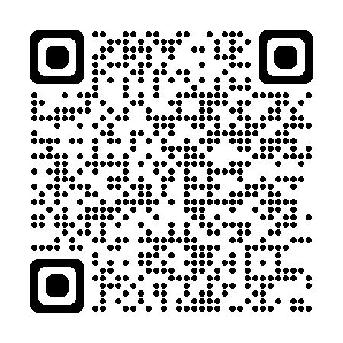
Inclusion: Inclusion Alberta is a family-based, non-profit federation that advocates on behalf of children and adults with developmental disabilities and their families. Inclusion Alberta works to foster family leadership and advocacy in the pursuit of fully inclusive community lives for children and adults with developmental disabilities. https://inclusionalberta.org/about-us/

